1957 2017
Joan & Dermot
Special Blessings On Your

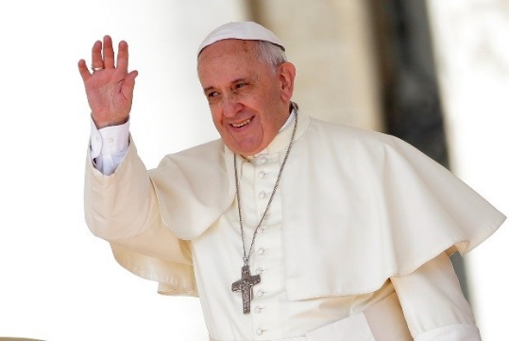

DiamondWedding Anniversary

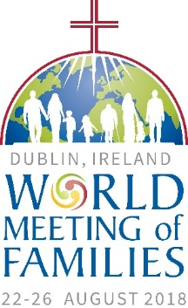
Marriage is also the experience of belonging completely to another person.
(Amoris Laetitia – The Joy of Love, 319)

