Were You Married
in 1992, 1977, 1967, 1957 or 1947?
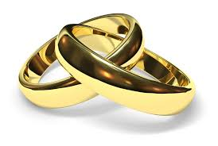
You are invited to join the Parish Community of
_______________________
At a Mass of Thanksgiving
on
Saturday 14 October 2017 at 6.00 p.m.
as we celebrate with those who are marking
Silver, Ruby, Golden, Diamond and Platinum
Wedding Anniversaries
This includes people who may be widowed
Refreshments will be offered afterwards in the Parish Centre
Please let the Parish Secretary know that you wish to be there – Tel. 01…../ or @eircom.net
and we’ll take it from there.
Were You Married
in 1992, 1977, 1967, 1957 or 1947?
You are invited to join the Parish Community of
____________________________
At a Mass of Thanksgiving
on
Sunday 15 October 2017 at 11.00 a.m.
as we celebrate with those who are marking
Silver, Ruby, Golden, Diamond and Platinum
Wedding Anniversaries
This includes people who may be widowed
Refreshments will be offered afterwards in the Parish Centre
Please let the Parish Secretary know that you wish to be there – Tel. 01…../ or @eircom.net
and we’ll take it from there.

