Order of Baptism

________Name_________

Date

Church of ….

Welcome, naming, signing with the cross

Fr.: [To parents] We will be known by our names in this life and in eternity, so I ask you what names have you chosen for your daughter?
Parents: …..
P: And what do you ask of God’s family, the Church
for ….?
Parents: The grace of Baptism

P: You have asked to have your child baptised. In doing so you are accepting the responsibility of bringing her up in the practice of the faith. It will be your duty to teach her to keep God’s commandments as Christ Jesus taught us, by loving God and our neighbour. Do you clearly understand what you are undertaking?
Parents: We do
P: [godparents] Are you ready to help these parents in their duty as a Christian mother and father?
Godparents: We are.
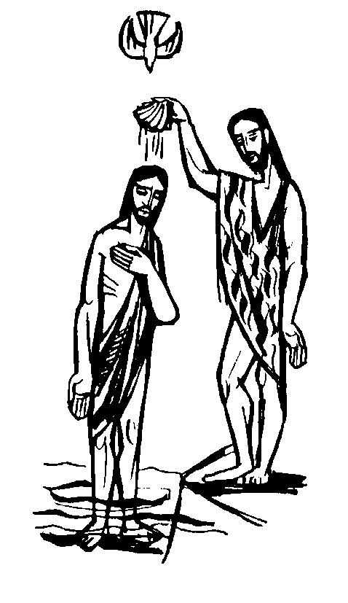
P: My dear child,
the Christian community
welcomes you with great joy.
In its name I claim you for
Christ our Saviour
by the sign of the cross.
I now trace the Sign of the Cross
on your forehead and I invite
your parents,
godparents and grandparents
to do the same.

Liturgy of the Word
We now sit to listen to God’s Word.
Reading
A Reading from the letter of St. Paul to the Philippians 4:4-8
I want you to be happy, always happy in the Lord; I repeat, what I want is your happiness. Let your tolerance be evident to everyone: the Lord is very near. There is no need to worry; but if there is anything you need, pray for it, asking God for it with prayer and thanksgiving, and that peace of God, which is so much greater than we can understand will guard your hearts and your thoughts, in Christ Jesus. Finally, fill your minds with everything that is true, everything that is noble, everything that is good and pure, everything that we love and honour, and everything that can be thought virtuous or worthy of praise.
The Word of the Lord. All: Thanks be to God
Psalm 26: The Lord is my light and my help
We Stand
Gospel Acclamation Seinn Aililiúia (Traditional)

Gospel Mark 1:9-11
Jesus came from Nazareth in Galilee
and was baptised in the River Jordan by John.
No sooner had he come up out of the water
than he saw the heavens torn apart
and the Spirit, like a dove, descending on him.
And a voice came from heaven,
‘You are my Son, the Beloved; my favour rests on you.’
The Gospel of the Lord.
All: Praise to you Lord Jesus Christ.
WE SIT

Homily

Prayer of the Faithful
P: Let us ask our Lord Jesus Christ to look lovingly on … who is to be baptised, on her parents, godparents and on all the baptised.
1. By the mystery of your death and resurrection,
bathe this child in light, give her new life in you
through baptism and welcome her into your holy Church.
Lord hear us All: Lord graciously hear us
2. Lead her by a holy life to the joys of God’s kingdom.
Lord hear us. All: Lord graciously hear us
3. May the lives of her parents and godparents be examples of faith and goodness to inspire her.
Lord hear us All: Lord graciously hear us
4. Keep her family always in your love.
Lord hear us All: Lord graciously hear us
5. Renew the grace of our baptism in each one of us
Lord hear us All: Lord graciously hear us

Invocation of the Saints
P: Since we are about to welcome a new member
into the family of God, let us ask our friends in the communion of saints to help us by their prayers:

Holy Mary Mother of God Pray for us
St. John the Baptist Pray for us
St Joseph Pray for us
St Peter and St Paul Pray for us
St James and St John Pray for us
St Francis Pray for us
St. Elizabeth Pray for us
St. Patrick Pray for us
St. Brigid Pray for us
St Columba Pray for us
St. Kevin Pray for us
All holy men and women saints Pray for us
Anointing with the Oil of Catechumens
P: Almighty God you sent your only Son to rescue us from the slavery of sin and to give us the freedom only your sons and daughters enjoy. We now pray for … who will have to face this world and its temptations. Your Son died and rose to save us. By this victory over sin and death bring … out of the power of darkness. Strengthen her with the grace of Christ and watch over her at every step of life’s journey.
We ask this through Christ our Lord. All: Amen

P: …, I anoint you with the oil of salvation
in the name of Christ our saviour. May Jesus strengthen you with his power, who lives and reigns forever and ever. All: Amen
The Blessing of the Water
P: Father, God of mercy, through these waters of baptism you have filled us with new life as your very own children. All: Blessed be God
P: From all who are baptised in water and the Holy Spirit, you have formed one people, united in your Son, Jesus Christ. All: Blessed be God
P: You have set us free and filled our hearts with the Spirit of your love that we may live in your peace.
All: Blessed be God
P: You call those who have been baptised to announce
the Good News of Jesus Christ to people everywhere
All: Blessed be God
P: You have called your child … to this cleansing water and new birth, that by sharing the faith of your Church she may have eternal life.

Bless + this water in which she will be baptised.
We ask this in the name of Jesus the Lord. All: Amen

Renunciation of Evil and Profession of Faith
P: Dear Parents and Godparents, you have asked to have … baptised. By water and the Holy Spirit she will receive the gift of new life from God who is love.
It will be your constant care to bring her up in the practice of the faith. Baptism is parent’s day too, since you publicly promise to hand on the faith you received. And so I ask you:

P: Do you reject Satan?
I do
And all his works?
I do
And all his empty promises?
I do
Do you believe in God, the Father almighty,
creator of heaven and earth? I do.
Do you believe in Jesus Christ, his only Son, our Lord,
who was born of the Virgin Mary, was crucified, died and was buried, rose from the dead, and is now seated at the right hand of the Father? I do.
Do you believe in the Holy Spirit, the holy catholic Church, the communion of saints, the forgiveness of sins, the resurrection of the body, and life everlasting? I do.

Let us all say together:
All: This is our faith. This is the faith of the Church.
We are proud to profess it, in Christ Jesus our Lord, Amen.

Baptism:
P: Parents, is it your will that … should be baptised in the faith of the Church which we have professed with you? It is
P: …., I baptise you in the name of the Father, and of the Son, and of the Holy Spirit.
Amen.

Anointing with the Oil of Chrism
P: …, God the Father of our Lord Jesus Christ has freed you from sin, given you a new birth by water and the Holy Spirit, and welcomed you into his Holy people. He + anoints you with the Chrism of Salvation.
As Christ was anointed Priest, Prophet, and King,
so may you live as a member of his body,
sharing everlasting life. Amen.
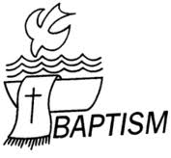

Clothing with a white robe
P: … you have become a new creation,
clothed in Christ. See in this white garment
the outward sign of your Christian dignity.
With your family and friends to help you
by word and example, bring that dignity unstained
into the everlasting life of heaven. Amen.

Presentation of the lighted Candle
P: …, receive the light of Christ.

Parents and Godparents, this light is entrusted to you to be kept burning brightly. … has been enlightened by Christ. May she walk always as a child of the light. May she keep the flame of Faith alive in her heart. When the Lord comes may she go out to meet him with all the saints in Heaven.
Prayer over the ears and mouth – the Ephphetha
P: The Lord Jesus made the deaf hear and the dumb speak. May he soon touch your ears to receive his Word and your mouth to proclaim his faith, to the praise and glory of God the Father. Amen.

Concluding Rite
P: Dear Friends, … has now been baptised in Christ. Now she is called a child of God, for indeed that is what she is. In confirmation she will receive the seal of God’s Spirit. In Holy Communion she will share in the Eucharist, calling God her Father in the midst of the Church. In the spiritual bond of our being God’s children, let us pray together in the words our Brother and Saviour gave us:

All: Our Father...

Blessings
A Blessing for Mother:
P: May God the source of life and love, who fills the hearts of mothers with love for their children, bless. As she thanks God for the birth of …, may she find joy in the love, growth and holiness of her child. All: Amen

A Blessing for Father:
P: God is the giver of all life, human and divine. May he bless Walter. Together with mother he will be … first teacher in the ways of faith. May he also be the best of teachers bearing witness to the faith by what he says and does. All: Amen.

A Blessing for all who are present:
P: May God bless all the relatives and friends who are gathered here. In his mercy may he guard you from evil and give you his abundant peace. May your friendship and prayers be a loving support to … throughout her life. All: Amen

P: And may almighty God bless you,
the + Father, the Son and Holy Spirit.
All: Amen
P: Let us bless the Lord.
All: Thanks be to God.
