Sign of the Cross

Prayer in the Home for the Deceased

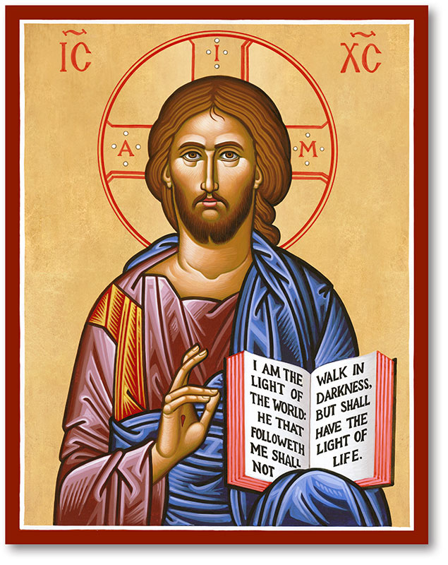

Praying for our loved ones who have died
This short prayer service is offered to families for use in the home on the death of a family member during this time of covid-19 pandemic. They may also be used by all who wish to pray at home for the deceased person.
The Christian community cannot now physically unite in prayer. However, be assured that the Church and her members continue to pray for the dead and for those who mourn them.

As you pray these prayers individually or together as a family, may you know the consolation and the support of the family of God. We are with you in prayer and in faith, hope and love.

‘Blessed are those who mourn.
They will be comforted.’
(Matthew 5:4)

In the name of the Father, and of the Son, and of the Holy Spirit. Amen.

We offer this time of prayer for ourselves and for our beloved N.
May it give us consolation and hope, and strength for the days ahead.

Prayer for the bereaved and the Deceased

Lord Jesus,
You hold out a hand of love to so many who seek your help.
Take hold of our hands this day
and see us through this time of sorrow and loss.
Renew our faith in your healing touch
and help us to place our trust in your gentle care.
In the days that lie ahead, keep us close to you,
that we may find comfort and peace
in the nearness of your unfailing love.
We pray for N. and commend him/her to your love and compassion.
Forgive N. his/her sins,
and grant him/her a place of happiness, light and peace
in the kingdom of your glory forever. R. Amen.

The Word of God John 14:1-3
Brothers and sisters, Jesus says:
‘Do not let your hearts be troubled.
Trust in God still and trust in me.
There are many rooms in my Father’s house;
if there were not, I should have told you.
I am going now to prepare a place for you,
and after I have gone and prepared you a place,
I shall return to take you with me,
so that where I am
you may be too.’

Pause for silent prayer for our deceased loved one

Family members may wish to share with one another and say thanks to God for different aspects of who their loved one was and of their life.

Prayers

In baptism N. died with Christ. May he/she now share the fullness of life with the Risen Lord. Lord, hear us. R. Lord, graciously hear us.

We pray that our family may find comfort through faith in Christ and the support of the Christian community. Lord, hear us. R. Lord, graciously hear us.

May we live our lives in the love of God’s presence. May we be reunited with N. some day when God calls us. Lord, hear us. R. Lord, graciously hear us.

We pray for all who care for the sick and the dying and for all our healthcare workers. Keep them safe and free from harm.
Lord, hear us. R. Lord, graciously hear us.

Guide with your wisdom all those who are working to protect us at this time of trial. Lord, hear us. Lord, graciously hear us.

We pray for all who have died, especially our relatives and friends, that they may enjoy eternal life in heaven. Lord, hear us. Lord, graciously hear us.

Our Father / Decade of the Rosary

Concluding Prayer
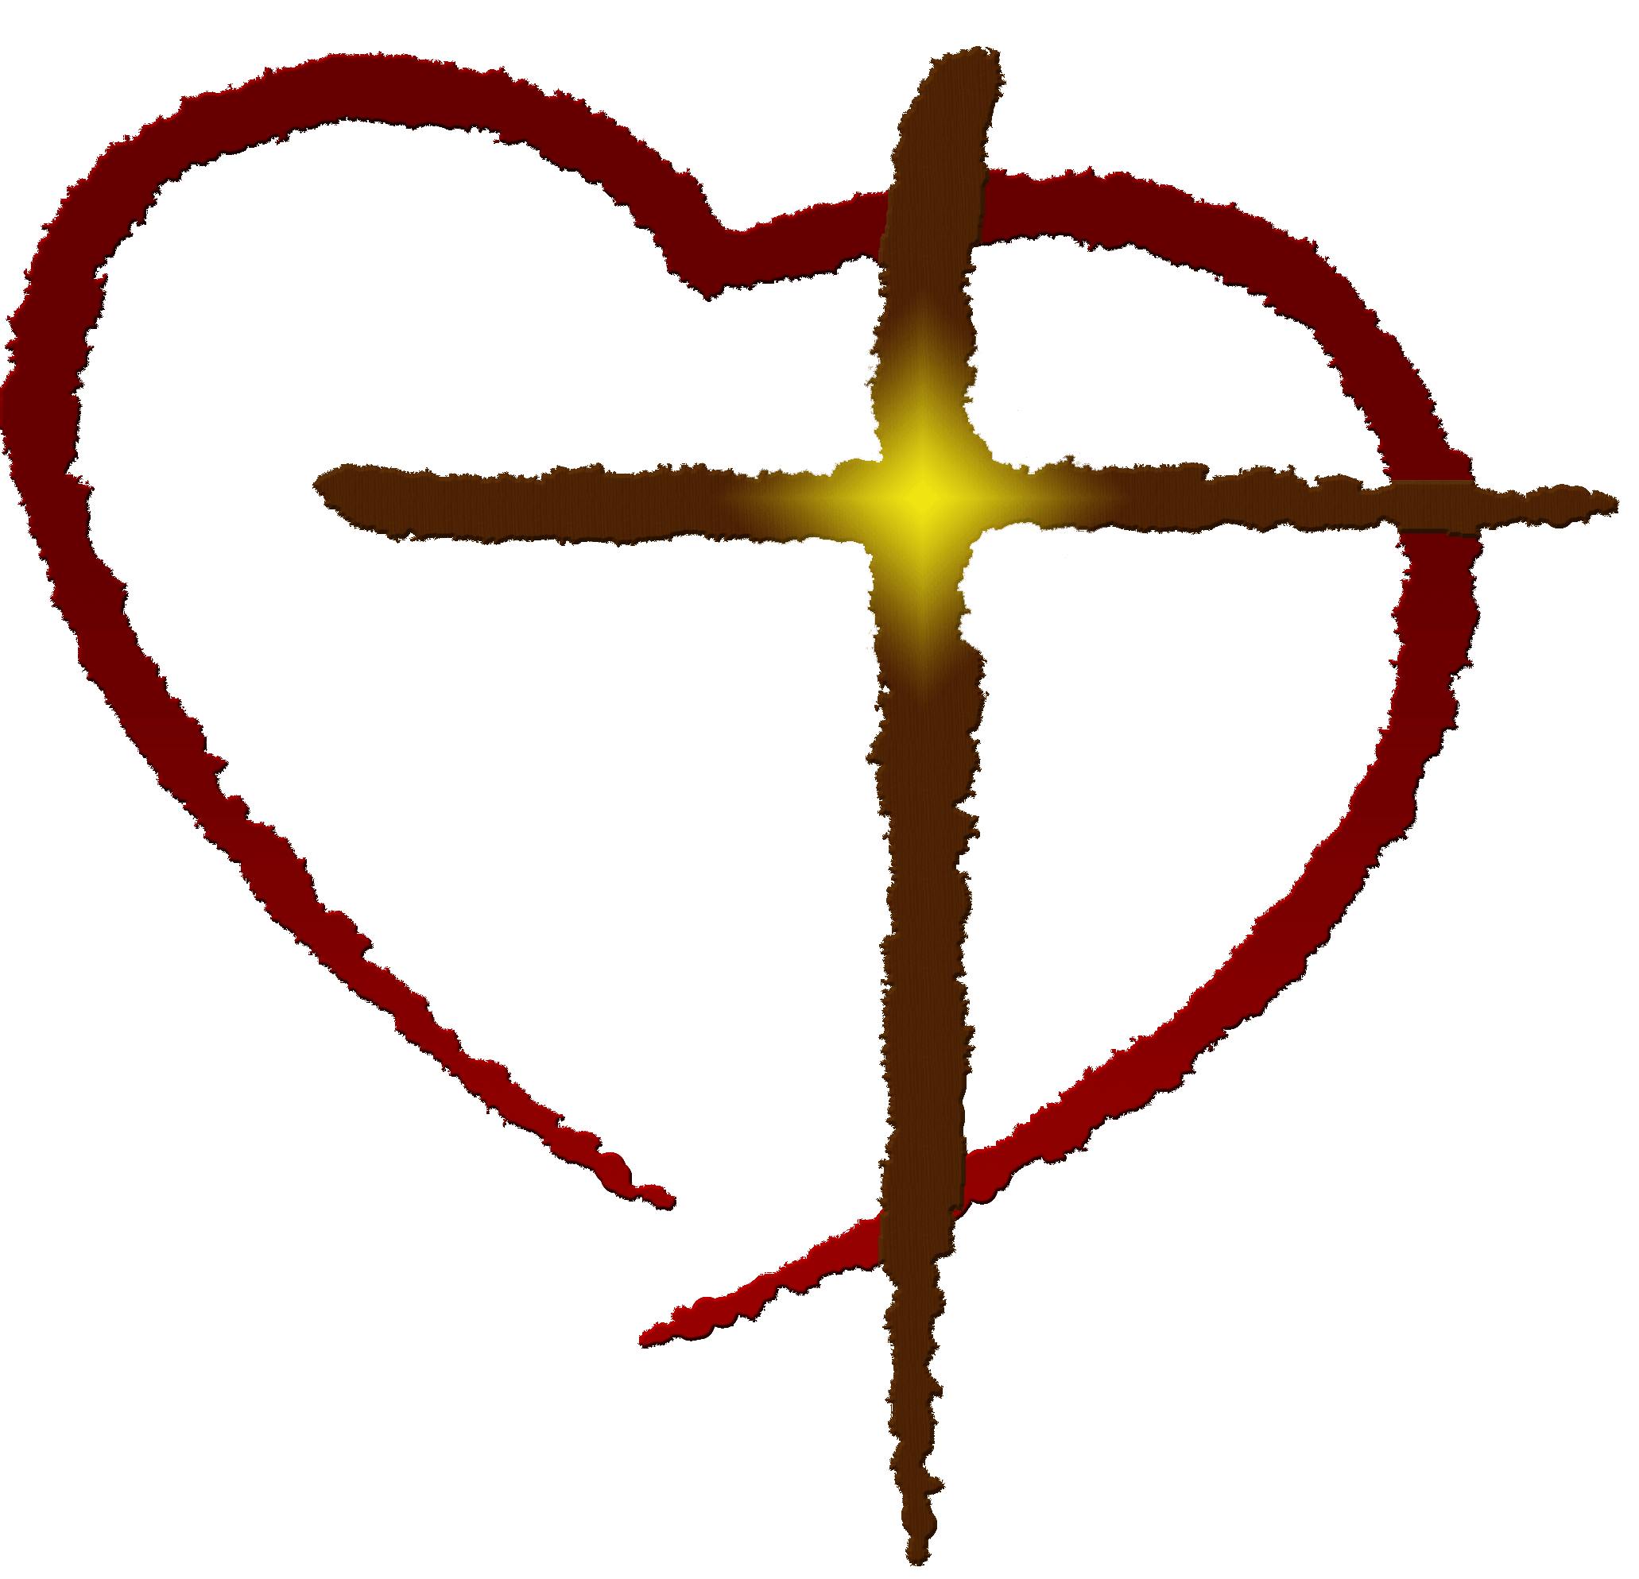
Lord God, You listen to the voice of our pleading.
Let us find in your Son,
comfort in our sadness,
certainty in our doubt,
and courage to live through this hour.
Make our faith strong
through Christ our Lord. Amen.

Conclusion

Eternal rest grant unto them, O Lord.
R. And let perpetual light shine upon them.
May they rest in peace.
R. Amen.
May their souls and the souls of all the faithful departed, through the mercy of God, rest in peace.
R. Amen.

And may the Lord support us all the day long, till the shadows lengthen and the evening comes, and the busy world is hushed, and the fever of life is over and our work is done. Then in His love and mercy may he give us and N. a safe lodging, a holy rest and peace at the last. Amen.

Sign of the Cross

In the name of the Father, and of the Son, and of the Holy Spirit. R. Amen.

Prepared by the Diocese of Kildare and Leighlin (March 2020)

