Service of Reconciliation - Examination of Conscience

- Our Father who art in heaven …
We’re all in this together. The Lord’s Prayer is a communal prayer just as this is a communal celebration of the Sacrament of Reconciliation. Jesus invites us to meet him in the Sacrament of Reconciliation not only as individuals but as members of a community of believers who have something in common.

Do we think of others when we pray or are we selfishly focused on ourselves?
Do we recognise the responsibility we share for each other’s welfare?

If we have failed in this way we ask forgiveness:
Lord, have mercy – Lord, have mercy

- Hallowed be Thy name …
We were made ‘holy’ by our Baptism and our mission is to preserve that grace throughout our lives.

Do we live lives that are truly wholesome and good?
Do we make an effort to develop a sense of holiness and respect for life?

If we have failed in this way we ask forgiveness:
Lord, have mercy – Lord, have mercy

- Thy Kingdom come
We can create heaven on earth by living up to the example of Jesus who was just, merciful and inclusive.

Do we build up the kingdom of justice and truth or do we destroy it by our greed?
Do we create an atmosphere of forgiveness or are hard and begrudging?

If we have failed in this way we ask forgiveness:
Lord, have mercy – Lord, have mercy

- Thy will be done on earth as it is in heaven
Jesus gives us the supreme example of obedience to the will of God by his prayer in the Garden of Gethsemane – ‘let thy will not mine be done’.

Do we avoid the hard things in life and take the easy way out?
Do we adopt the motto ‘my way or the highway’ because of pride and lack of humility?

If we have failed in this way we ask forgiveness:
A Thiarna, déan trócaire, A Thiarna, déan trócaire
- Give us this day our daily bread
This prayer encourages us to live in the present praying for our present needs and nourishment. It also opens up the challenge of acknowledging the needs of the whole community for both spiritual nourishment and the vital sustenance in life.

Do we waste time and energy in worrying about the future and ignoring the present?
Do we look beyond our own need for nourishment to the cause of victims of famine?

If we have failed in this way we ask forgiveness:
A Thiarna, déan trócaire, A Thiarna, déan trócaire

- And forgive us our trespasses
We need to know our weaknesses and failing before we can ask for forgiveness. This calls for a great deal of honesty, courage and humility.

Do we always blame others for our own mistakes ignoring the truth?
Do we take time to listen when others are trying to point out our faults?

If we have failed in this way we ask forgiveness:
A Thiarna déan trócaire, A Thiarna déan trócaire

- As we forgive those who trespass against us
These two phrases of the prayer go hand in hand. We don’t understand God’s forgiveness if we cannot forgive ourselves and others in turn?

Do we hold on to past hurts making our own lives and those of others a living hell?
Do we meet others half way or make it difficult to mend fences in relationships?

If we have failed in this way we ask forgiveness:
Christe eleison, Kyrie eleison, Christe eleison

- And lead us not into temptation
We all know the reality of the slippery slope of temptation – we think that we can be strong and full of resistance – the spirit is willing but the flesh is weak.

Do we avoid situations, people and places which will lead us to fall into bad habits?
Do suffer from the pride of thinking that we can manage our addictions on our own?

If we have failed in this way we ask forgiveness:
Christe, eleison, Kyrie, eleison, Christe, eleison

- But deliver us from evil
We are invited to place our trust in a God who will protect us from harm. However, we have to cooperate with God in allowing God to keep us from harm.

Do we dismiss the presence of evil in our arrogance?
Do we lack trust in God placing ourselves and our opinions above all else>

If we have failed in this way we ask forgiveness:
Christe eleison, Kyrie eleison, Christe eleison

Act of Sorrow
All say : O my God, I thank you for loving me.
I am sorry for all my sins,
For not loving others and for not loving you.
Help me to live like Jesus and try not to sin again.

Music Abwoon (Our Father) by Lisa Gerrard and Patrick Cassidy
Athair ar Neamh by Enya

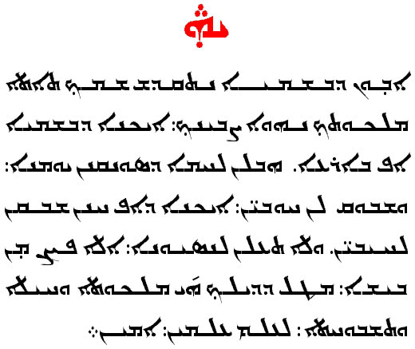
Our Father in Aramaic

