Ascension Sunday Reflection 2020

One of the many jokes around these days is about the Ascension – ‘the day Jesus started to work from home’. Apart from the humour it is an interesting concept.
Working remotely does not mean that we are not still at the heart of our business. We do but in a different way.

The Ascension left the disciples bewildered. What would they do without him? How could they continue on the mission that Jesus had initiated with them? In their upset they failed to take on board the words of Jesus ‘ I will be with you always; yes to the end of time ‘ (Matthew 28:20). With them but also in a different way.

We can see that confusion in an illustration of the Ascension from the Rabbula Gospels (6th century Syria). They point incredulously as Jesus is lifted up ‘and a cloud took him from their sight’ (Acts 1.10). In the middle of the group stands Mary wearing her red shoes of victory, perfectly calm and trusting, with her hands raised in the praying position. She was the sure footed disciple who stood there grounded in the assurance of her faith in the words of her Risen Son. ‘I will be with you always; yes to the end of time ‘.

Mary – The Sure Footed Disciple

The Ascension threw the others into confusion
But not you, Mary, in your red shoes of victory
Calm and composed you held it together prayerfully
Rooted in the present while others looked up in dismay
You showed yourself to be the sure footed disciple

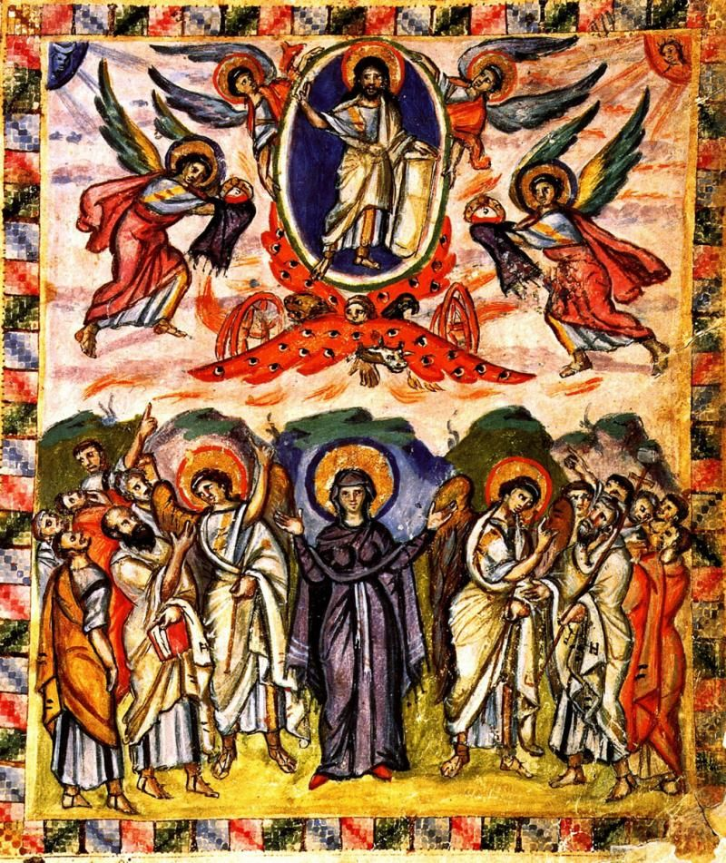
Rabbula Gospel Illustration – 6th c. Syria

