FAMILY MASS RESOURCE FOR CHRISTMAS VIGIL

ISAIAH 62:1 – 5
A reading from the prophet Isaiah
Because I love Jerusalem, I will continue to speak for her.
For Jerusalem’s sake I will not stop speaking.
I will speak until her goodness shines like a bright light.
I will speak until her salvation burns bright like a flame.
Jerusalem, the nations will see your goodness.
All kings will see your honour.
Then you will have a new name.
The Lord himself will give you that new name.
You will be like a beautiful crown in the Lord’s hand.
You will be like a king’s crown in your God’s hand.
You will never again be called the People that God Left.
Your land will never again be called the Land that God Destroyed.
You will be called the People God Loves.
Your land will be called the Bride of God.
This is because the Lord loves you.
And your land will belong to him as a bride belongs to her husband.
As a young man marries a woman,
so your children will marry your land.
As a man is very happy about his new wife,
so your God will be happy with you.

THE WORD OF THE LORD
THANKS BE TO GOD

Psalm 88
Response: I will always sing about the Lord’s love
I made an agreement with the man of my choice.
I made a promise to my servant David.
I told him, ‘I will make your family continue forever.
Your kingdom will continue from now on.’
I will always sing about the Lord’s love

Happy are the people who know how to praise you.
Lord, let them live in the light of your presence.
In your name they rejoice all the time.
They praise your goodness.
I will always sing about the Lord’s love

He will say to me, ‘You are my father,
my God, the Rock, the one who saves me.’
I will make him my firstborn son.
He will be the greatest king on earth.
I will always sing about the Lord’s love

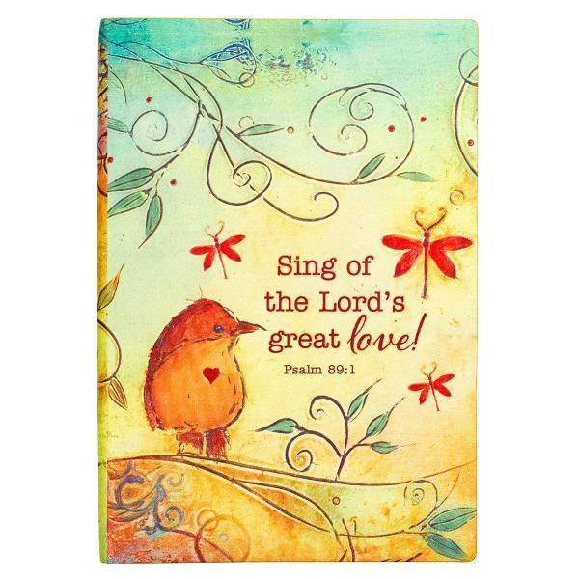

ACTS 13: 16 – 17, 22 – 25
A reading from the Acts of the Apostles
Paul stood up. He raised his hand and said,
“Men of Israel and you other people who worship God, please listen! The God of the people of Israel chose our ancestors. He made the people great during the time they lived in Egypt. He brought them out of that country with great power.
Then God made David their king.
This is what God said about him: ‘I have found David son of Jesse. He is the kind of man I want. He will do all that I want him to do.’
So God has brought one of David’s line to Israel to be their Saviour.
That descendant is Jesus. And God promised to do this.
Before Jesus came, John preached to all the people of Israel.
He told them about a baptism of changed hearts and lives.
When he was finishing his work, he said,
‘Who do you think I am? I am not the Christ.
He is coming later. I am not worthy to untie his sandals.’
THE WORD OF THE LORD
THANKS BE TO GOD

MATTHEW 1: 18 -25
A reading from the Holy Gospel according to Matthew
The mother of Jesus Christ was Mary. And this is how the birth of Jesus came about. Mary was engaged to marry Joseph. But before they married, she learned that she was going to have a baby. She was pregnant by the power of the Holy Spirit. Mary’s husband, Joseph, was a good man. He did not want to disgrace her in public, so he planned to divorce her secretly.
While Joseph thought about this, an angel of the Lord came to him in a dream. The angel said, “Joseph, son of David, don’t be afraid to take Mary as your wife. The baby in her is from the Holy Spirit. She will give birth to a son. You will name the son Jesus. Give him that name because he will save his people from their sins.”
All this happened to make clear the full meaning of what the Lord had said through the prophet: “The young woman will be pregnant. She will have a son, and they will name him Immanuel.” This name means “God is with us.”
When Joseph woke up, he did what the Lord’s angel had told him to do. Joseph married Mary. But he did not sleep with her until she gave birth to the son. And Joseph named the son Jesus.

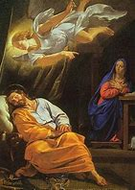

PRAYER OF THE FAITHFUL
When we look at Jesus in the Crib, we see that God is with us, let’s bring our prayers to him, knowing that he always answers us.

For Pope Francis and all who lead us in the Church,
That they may show the light of Jesus in all they do.
Lord hear us

For the children of the world and their families,
That they may share their love with each other and give to those who are poor.
Lord hear us

For peace in our world and our lives,
That the whole world may know that God is with us and share his peace and love.
Lord hear us

For those who are unwell at this time,
That they may know that God is with them at all times, sharing his peace and love.
Lord hear us

For those who have died and gone to heaven
That they may be happy with the Lord and look on us with love tonight.
Lord hear us

Suggested Offertory Hymn: Joseph’s Lullaby from the Emmanuel 2019 Album
Other child friendly hymns: Away in a manger, Silent Night, Come and Join the Celebration, Long time ago in Bethlehem, Joy to the world, Born in the night Mary’s child, He is here (Graham Kendrick)
FAMILY MASS RESOURCE FOR CHRISTMAS DAY

ISAIAH 62: 11 – 12
A reading from the prophet Isaiah
The Lord is speaking
to all the faraway lands:
“Tell the people of Jerusalem,
‘Look, your Saviour is coming.
He is bringing your reward to you.
He is bringing his payment with him.’
His people will be called the Holy People.
They will be called the Saved People of the Lord.
And Jerusalem will be called the City God Wants.
It will be named the City God Has Not Rejected.

PSALM 96
Today new light will shine upon the earth: the Lord is born for us
The Lord is king. Let the earth rejoice.
Faraway lands should be glad. The skies tell about his goodness.
And all the people see his glory.
Today new light will shine upon the earth: the Lord is born for us

Light shines on those who do right.
Joy belongs to those who are honest.
Rejoice in the Lord, you who do right.
Praise his holy name.
Today new light will shine upon the earth: the Lord is born for us

TITUS 3: 4 – 7
A reading from the letter to Titus
The kindness and love of God our Saviour was shown.
He saved us because of his mercy, not because of good deeds we did to be right with God.
He saved us through the washing that made us new people.
He saved us by making us new through the Holy Spirit.
God poured out to us that Holy Spirit fully through Jesus Christ our Saviour.
We were made right with God by His grace.
And God gave us the Spirit so that we could receive the life that never ends.
That is what we hope for.
THE WORD OF THE LORD
THANKS BE TO GOD

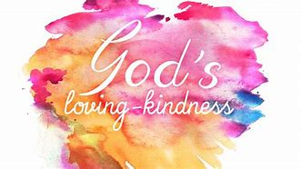

LUKE 2: 15 – 20
The angels left the shepherds and went back to heaven.
The shepherds said to each other, “Let us go to Bethlehem and see this thing that has happened. We will see this thing the Lord told us about.”
So, the shepherds went quickly and found Mary and Joseph.
And the shepherds saw the baby lying in a manger. Then they told what the angels had said about this child.
Everyone was amazed when they heard what the shepherds said to them.
Mary hid these things in her heart; she continued to think about them.
Then the shepherds went back to their sheep, praising God and thanking him for everything that they had seen and heard.
It was just as the angel had told them.

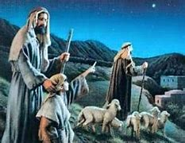

PRAYER OF THE FAITHFUL
Let us pray together on this Christmas morning that we will be like the shepherds and share the Good News that Jesus is born today.

For all who shepherd in the Church, especially Pope Francis
That he may show us the way to find Jesus in our lives.
Lord hear us
For all our family and friends
That they may know the joy of knowing Jesus in their homes this Christmas
Lord hear us
For children all over the world
That this may be a time of peace for them and that no child will be hungry this Christmas
Lord hear us
For those we love who are sick, at home or in hospital
That they will be surrounded by love and care this Christmas
Lord hear us
For those who have died and are now with the angels
That they will sing ‘Glory to God’ in heaven
Lord hear us

Offertory Hymn suggestion: O little town of Bethlehem

Other child friendly hymns: Away in a manger, Silent Night, Come and Join the Celebration, Long time ago in Bethlehem, Joy to the world, Born in the night Mary’s child, He is here (Graham Kendrick)

