A Blessing of School Backpacks
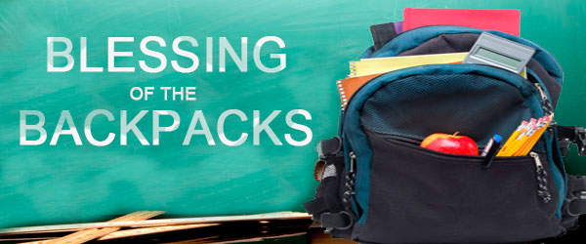
Here is a simple blessing that anyone could use at home or in class for the blessing of school bags at the start of the year….

- As you carry your bag, may you know that Jesus is walking with you always looking after you.

- May you keep safe in all you do, may you be more aware of others too.

- May you know the warmth of God’s protecting presence in all you say and do.

- May the Lord help you at school, to grow in every way.

After these prayers, sprinkle the bags with some Holy Water, if you have some.

+++++++++++

This can also be used at the end of Mass, before the final blessing, using the following introduction:

Let us pray for God’s blessing on our children in this new school year, that they may continue to walk safely in God’s ways……….

