BE STILL
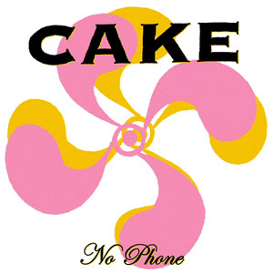
The overall theme of our December Family Year and Advent resources is ‘Be Still’. We are suggesting that as the family gathers for the main meal in the day that all take one minute of quiet as a time of calm. A little bell or a sand timer can be used to announce the beginning and end of the period. What about putting all phones into a basket outside the room? As you retrieve your phone, after the meal, you can pick up a small treat.

Silent waiting in Advent - We are not there yet
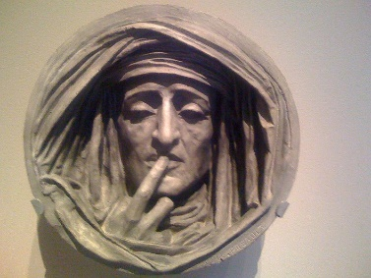
Sometimes waiting feels good…like when we are looking forward to meeting someone, or waiting to go on holidays…. Advent waiting is different to waiting for the bus to come, or the phone to ring. When it is good to wait, it is because we believe that we will be fulfilled, that something wonderful and great will happen. Advent invites us to wait……to wait consciously……….to wait openly for God……...to wait and notice God in our lives…in the bits and pieces of everyday…and in the silence. Advent invites us to live each day in expectation ……. God is not in the past, in all our mistakes and failings and things we have left undone. God is not in the future, in all things we are rushing to do. God is in the present, trying to break through, to become incarnate in our world right now, in this moment. But only those who are waiting…..in silence…. expecting.... watching for something wonderful….. will notice.

The Slow Track to Bethlehem
When do you put up your crib? There are different family traditions. What about Gaudete Sunday, 12 December 2021. On this Sunday the rose or pink candle is lit in the advent wreath. The figure of the baby Jesus will have been blessed at Mass that morning and hidden in the house. Set up the crib structure with the ‘expectant’ straw in it but no figures. Station the figures around the house in order of their appearance – kings coming last. Gradually move them nearer to the empty crib. On Christmas Eve morning put in Mary, Joseph and the animals. Young family members will search for the figure of Jesus. In the night, the Baby Jesus is placed between the loving gaze of Mary and Joseph with angels and shepherds making their timely appearance. The journey to Bethlehem has many stages. If you stay with the silent movement of the figures as you journey with them you might find that they come alive in your heart.

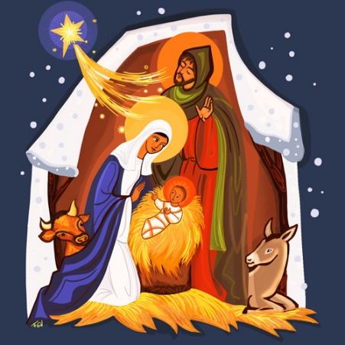
©Benedictines de Vanier

In the stillness of Advent, you are invited to pray regularly the Synodal Pathway Prayer.
It will be recited in our parish churches at all Masses during the Advent season. You can include it in your own quiet prayer moments breaking it up into sections for deeper reflection throughout the day. For home prayer too, you might light a candle to call the light of the Holy Spirit to shine into the hearts of all who walk the Synodal Pathway.
