Act of Consecration
to the Immaculate Heart of Mary
Solemnity of the Annunciation - 25 March 2022

Entrance Song Holy Mary Full of Grace (Abbé Paul Décha)
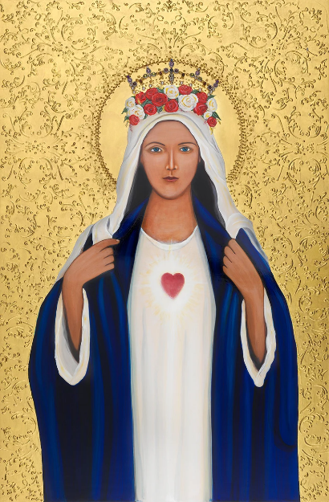
All sing: When creation was begun, God had chosen you to be
Mother of his blessed Son, Holy Mary full of grace.
Ave, Ave, Ave Maria.

When creation was restored, you were there beside the Lord
Whom you cherished and adored, Holy Mary, full of grace.
Ave, Ave, Ave Maria.

All of us are children too, often doubtful what to do,
Needing to confide in you, Holy Mary, full of grace.
Ave, Ave, Ave Maria.

Introduction In ainm an Athar agus an Mhic agus an Spioraid Naoimh
Amen.
Peace be with you
And with your spirit.

Welcome Archbishop Dermot Farrell

Prayer MARY – Woman of Listening (Pope Francis)
Mary, woman of listening, open our ears;
grant us to know how to listen to the word of your Son Jesus among the thousands of words of this world;
grant that we may listen to the reality in which we live,
to every person we encounter, especially those who are poor, in need, in hardship.

Mary, woman of decision, illuminate our mind and our heart, so that we may obey, unhesitating, the word of your Son Jesus; give us the courage to decide, not to let ourselves be dragged along, letting others direct our life.

Mary, woman of action, obtain that our hands and feet move “with haste” toward others, to bring them the charity and love of your Son Jesus, to bring the light of the Gospel to the world, as you did. Amen.

Gospel Acclamation
All sing: Praise and honour to you, Lord Jesus Christ
Gospel Luke 1:26-38
The angel Gabriel was sent from God to a town of Galilee called Nazareth,
to a virgin betrothed to a man named Joseph, of the house of David, and the virgin’s name was Mary.
And coming to her, he said, “Hail, full of grace! The Lord is with you.”
But she was greatly troubled at what was said and pondered what sort of greeting this might be.
Then the angel said to her, “Do not be afraid, Mary, for you have found favour with God.
Behold, you will conceive in your womb and bear a son, and you shall name him Jesus.
He will be great and will be called Son of the Most High, and the Lord God will give him the throne of David his father,
and he will rule over the house of Jacob forever, and of his Kingdom there will be no end.”
But Mary said to the angel, “How can this be, since I have no relations with a man?”
And the angel said to her in reply, “The Holy Spirit will come upon you, and the power of the Most High will overshadow you. Therefore, the child to be born will be called holy, the Son of God.
And behold, Elizabeth, your relative, has also conceived a son in her old age, and this is the sixth month for her who was called barren;
for nothing will be impossible for God.”
Mary said, “Behold, I am the handmaid of the Lord. May it be done to me according to your word.” Then the angel departed from her.

Homily Archbishop Dermot Farrell

Reflection Lady Mary (Thomas Merton OSCO)
Lady Mary, you whose “yes” opened the door to our salvation, show us how we can say “yes” without reservations. Teach us to wait,
as we hang in the balance of the past and the possible. Let us make loving choices as you did, agreeing freely to God’s plan for us. Mother us as we make our way to your Son. Amen.

Prayer 1 ‘O Mary, Mother of God and our Mother, in this time of trial we turn to you. As our Mother, you love us and know us: no concern of our hearts is hidden from you. Mother of mercy, how often we have experienced your watchful care and your peaceful presence! You never cease to guide us to Jesus, the Prince of Peace.
Yet we have strayed from that path of peace. We have forgotten the lesson learned from the tragedies of the last century, the sacrifice of the millions who fell in two world wars. We have disregarded the commitments we made as a community of nations. We have betrayed peoples’ dreams of peace and the hopes of the young. We grew sick with greed, we thought only of our own nations and their interests, we grew indifferent and caught up in our selfish needs and concerns. We chose to ignore God, to be satisfied with our illusions, to grow arrogant and aggressive, to suppress innocent lives and to stockpile weapons. We stopped being our neighbour’s keepers and stewards of our common home. We have ravaged the garden of the earth with war and by our sins we have broken the heart of our heavenly Father, who desires us to be brothers and sisters. We grew indifferent to everyone and everything except ourselves. Now with shame we cry out: Forgive us, Lord!’ (Pause)
Act of Forgiveness Archbishop Farrell
May almighty God have mercy on us, forgive us our sins
and bring us to everlasting life. Amen.
Kyrie (Plainchant) Kyrie Eleison, Christe Eleison, Kyrie Eleison

Prayer 2 “Holy Mother, amid the misery of our sinfulness, amid our struggles and weaknesses, amid the mystery of iniquity that is evil and war, you remind us that God never abandons us, but continues to look upon us with love, ever ready to forgive us and raise us up to new life. He has given you to us and made your Immaculate Heart a refuge for the Church and for all humanity. By God’s gracious will, you are ever with us; even in the most troubled moments of our history, you are there to guide us with tender love.
We now turn to you and knock at the door of your heart. We are your beloved children. In every age you make yourself known to us, calling us to conversion. At this dark hour, help us and grant us your comfort. Say to us once more: “Am I not here, I who am your Mother?” You are able to untie the knots of our hearts and of our times. In you we place our trust. We are confident that, especially in moments of trial, you will not be deaf to our supplication and will come to our aid.”

Song Ag an bPósadh Bhí I gCána (Traditional Irish)

Prayer 3 “‘That is what you did at Cana in Galilee, when you interceded with Jesus and he worked the first of his signs. To preserve the joy of the wedding feast, you said to him: “They have no wine” (Jn 2:3). Now, O Mother, repeat those words and that prayer, for in our own day we have run out of the wine of hope, joy has fled, fraternity has faded. We have forgotten our humanity and squandered the gift of peace. We opened our hearts to violence and destructiveness. How greatly we need your maternal help!”

All say: Therefore, O Mother, hear our prayer.
Star of the Sea, do not let us be shipwrecked in the tempest of war.
Ark of the New Covenant, inspire projects
and paths of reconciliation.
Queen of Heaven, restore God’s peace to the world.
Eliminate hatred and the thirst for revenge,
and teach us forgiveness.
Free us from war, protect our world from the menace
of nuclear weapons.
Queen of the Rosary, make us realize our need to pray and to love.
Queen of the Human Family, show people the path of fraternity.
Queen of Peace, obtain peace for our world.’

Song Mother of Christ (James Quinn S.J.)

Prayer 4 “O Mother, may your sorrowful plea stir our hardened hearts. May the tears you shed for us make this valley parched by our hatred blossom anew. Amid the thunder of weapons, may your prayer turn our thoughts to peace. May your maternal touch soothe those who suffer and flee from the rain of bombs. May your motherly embrace comfort those forced to leave their homes and their native land. May your Sorrowful Heart move us to compassion and inspire us to open our doors and to care for our brothers and sisters who are injured and cast aside.”

Song ctd. 2. Mother of Christ, Mother of Christ, I toss on a stormy sea, O lift thy child as a beacon high to the port where I fain would be, Then, Mother of Christ, Mother of Christ, This do I ask of thee, when the voyage is o'er, O stand on the shore and show Him at last to me.

Prayer 5 “Holy Mother of God, as you stood beneath the cross, Jesus, seeing the disciple at your side, said: “Behold your son” (Jn 19:26). In this way he entrusted each of us to you. To the disciple, and to each of us, he said: “Behold, your Mother” (v. 27). Mother Mary, we now desire to welcome you into our lives and our history. At this hour, a weary and distraught humanity stands with you beneath the cross, needing to entrust itself to you and, through you, to consecrate itself to Christ. The people of Ukraine and Russia, who venerate you with great love, now turn to you, even as your heart beats with compassion for them and for all those peoples decimated by war, hunger, injustice and poverty.”

A Lenten Litany for Ukraine
For all who seek safe shelter,
Suffering Christ, born in a manger, hear our cry.
For all who are desperate to cross borders,
Suffering Christ, fleeing to Egypt, hear our cry.
For all who have been separated from their families,
Suffering Mary, searching for the Christ child, hear our cry.
For all who are locked in the constant grip of fear and grief, Suffering Christ, sweating blood in the garden, hear our cry.
For all who feel betrayed and forgotten,
Suffering Christ, sold for thirty coins, hear our cry.
For all who seek to shield their children from violence,
Suffering Mary, gazing upon the cross, hear our cry.
For all who have lost hope of resolution,
Suffering Christ, crowned with thorns, hear our cry.
For all who are losing their lives in this war,
Suffering Christ, breathing your last, hear our cry.
May our tears join together as a holy river, rushing with salt and sorrow to the source of the sea - the blood and water that flow from your pierced side. Suffering Christ, hear our cry.

Invitation to Pause before Act of Consecration (Archbishop Dermot Farrell)
Act of Consecration
“Therefore, Mother of God and our Mother, to your Immaculate Heart we solemnly entrust and consecrate ourselves, the Church and all humanity, especially Russia and Ukraine. Accept this act that we carry out with confidence and love. Grant that war may end and peace spread throughout the world. The “Fiat” that arose from your heart opened the doors of history to the Prince of Peace. We trust that, through your heart, peace will dawn once more. To you we consecrate the future of the whole human family, the needs and expectations of every people, the anxieties and hopes of the world.

Through your intercession, may God’s mercy be poured out on the earth and the gentle rhythm of peace return to mark our days. Our Lady of the “Fiat”, on whom the Holy Spirit descended, restore among us the harmony that comes from God. May you, our “living fountain of hope”, water the dryness of our hearts. In your womb Jesus took flesh; help us to foster the growth of communion. You once trod the streets of our world; lead us now on the paths of peace. Amen.”

Song Ave Maria (Caccini)
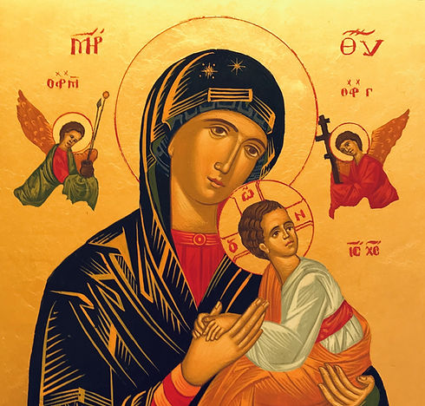

Concluding Prayer Rejoice, Virgin Birthgiver-of-God,
Mary, Full of Grace, the Lord is with you.
It is right, in truth, to call you Blessed, Birthgiver-of-God,
Ever-Blessed, Most Pure and the Mother of our God.
Beneath your tender mercy we flee, Birthgiver-of-God.
Reject not our prayer in our trouble, but deliver us from harm, Only Pure and Blessed Lady. Amen
Most Glorious Ever-Virgin Mary, Mother of Christ our God, receive our prayer and present it to your Son and our God, that, for your sake, He may save lives and souls. Amen.

Song Salve Regina (Plainchant)

Final Words Monsignor Ciarán O’Carroll
Concluding Song Make Me A Channel of Your Peace (Sebastian Temple)
All sing: Make me a channel of your peace
Where there is hatred let me bring your love
Where there is injury, your pardon Lord
And where there is doubt true faith in You
Make me a channel of your peace
Where there is despair in life let me bring hope
Where there is darkness only light
And where there's sadness ever joy
Oh, Master grant that I may never seek
So much to be consoled as to console
To be understood as to understand
To be loved as to love with all my soul
Make me a channel of your peace
It is in pardoning that we are pardoned
It is in giving to all that we receive
And in dying that we are born to eternal life
Oh, Master grant that I may never seek
So much to be consoled as to console
To be understood as to understand
To be loved as to love with all my soul.
Make me a channel of your peace
It is in pardoning that we are pardoned
It is in giving to all that we receive
And in dying that we are born to eternal life.
