Reading John 14: 27
Peace I bequeath to you,
My own peace I give you,
A peace the world cannot give,
this is my gift to you.

Prayer Let us pray,
All say: God of love and tenderness,
Help us to be patient as we build pathways for peace
Give us the grace to love others unconditionally
Inspire us to see with our hearts.
Let your light shine on all those who have died as a result of war or terrorism especially in Ukraine.
We ask this through Christ, our Lord. Amen.

Reflection Peace Bringer – Joyce Rupp
Not all wars consist of armoured soldiers.
Many take place within feuding individuals
Where jealousy, anger, and hatred exist.
Peace Bringer, come to all hearts at war.
Move them to lay down their weapons,
To cast aside bitterness and resentment.
Bring your peace to hard-hearted ones.
Lessen the grip of those who desire revenge.
May your peace release whatever binds
And free all those held captive by hostility.

Resolution Make us instruments of Your peace
Where there is hatred, let Your love increase Lord,
make us instruments of Your peace,
Walls of pride and prejudice shall cease
When we are Your instruments of peace
Where there is hatred, we will show His love
Where there is injury, we will never judge
Where there is striving, we will speak His peace
To the millions crying for release
We will be God’s instruments of peace
Where there is blindness, we will pray for sight
Where there is darkness, we will shine His light
Where there is sadness, we will bear their grief
To the millions crying for relief
We will be Your instruments of peace.

Ash Wednesday 2022

Song Bless The Lord (Taizé)
All sing: Bless the Lord, my soul, and bless God’s holy name
Bless the Lord my soul, who leads me into life.

Opening Prayer Let us pray,
Grant, O Lord, that we may begin with holy fasting
this campaign of Christian service,
so that, as we take up battle against spiritual evils,
we may be armed with weapons of self-restraint.
Through our Lord Jesus Christ, your Son,
who lives and reigns with you in the unity of the Holy Spirit,
one God, for ever and ever. Amen.
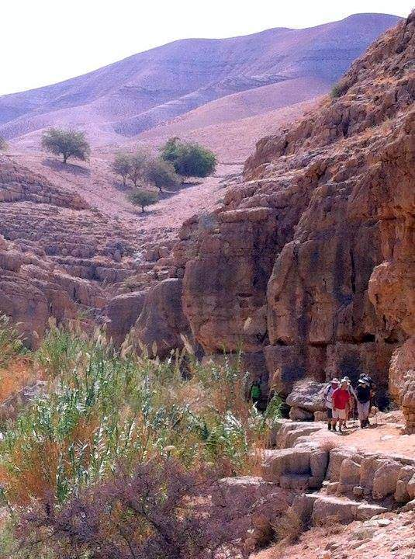

Reading Mt 4:1-11
Jesus was led by the Spirit out into the wilderness to be tempted by the devil.
Taking him to a very high mountain, the devil showed him
all the kingdoms of the world and their splendour. ‘I will give you all these’, he said, ‘if you fall at my feet and worship me.’
Then Jesus replied, ‘Be off, Satan! For scripture says:
You must worship the Lord your God,
and serve him alone.’
Then the devil left him, and angels appeared and looked after him.

Prayer
All say: I let go of my desire for power and control.
I let go of my desire for affection, esteem,
approval and pleasure.
I let go of my desire for survival and security.
I let go of my desire to change any situation,
condition, person or myself.
I open to the love and presence of God and
God's action within. Amen.

Blessing and Distribution of Ashes

