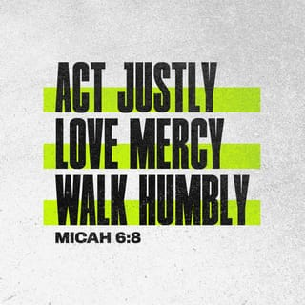Act…Love…Walk
Preparing for the Sacrament of Reconciliation

Reading Micah 6:8
What does the Lord require of you?
To act justly, to love mercy
and to walk humbly with your God.

ACT JUSTLY

Song The Water of Life (Marie Dunne CHF)

All sing: Come to the water you who are thirsty, come to the water of life.

Though you have nothing, I am your all, I will hear you when I call.

Reflection What is Water Justice?
‘Water is Life. People not having clean water is very much a justice
issue. They spend hours getting water for their household needs –
then there are health concerns around the water they drink. I try to
make a difference where I can, even little things ’
Father Phillip - Lingoni Parish Malawi. (Pause)

Reading Amos 5.24
Let justice flow like a river,
Righteousness like a never-failing stream

‘Even where poverty bites deep. Even in a changing climate. Solar powered
water pumps, and boreholes. Simple drip irrigation pipes, and hardy diverse seeds for planting. Each a ripple of justice, a tenacious ray of hope.’
Trócaire 2024.
All say: Let justice flow like a river,
Righteousness like a never-failing stream

‘Multiple times a day, over steep terrain, Malita (mother of twins Patricia and
Patrick) hauls two 20-litre buckets – up to 40 kilos of water. Its backbreaking
work for water that sometimes makes her family sick.’
Trócaire 2024.
All say: Let justice flow like a river,
Righteousness like a never-failing stream
(Pause)
What can we do?
One example of justice in action is from Blessed Maria Celeste Crostarosa, who
founded the Redemptoristines. In her early years, she set up an orphanage,
where she not only provided shelter but also ensured that children received an
education. She believed in the power of small acts of justice and calls us to do
the same.
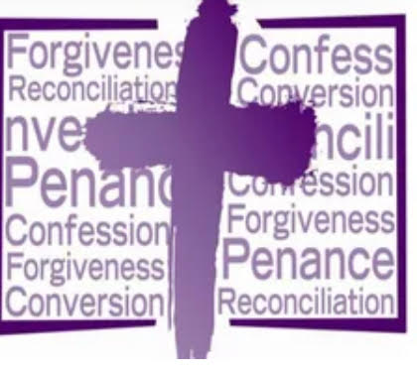
Sr. Lucy

Act of Sorrow
We are sorry for the continued draining and destruction of
our seas through overfishing Kyr
We are sorry for our pollution of the rivers and lakes Christe
We are sorry for failing to prioritise clean water as a common
good for all Kyrie (Pause)

LOVE MERCY

Song Remember, Remember (Paul Inwood)
All sing: Remember, remember, your mercy, Lord.
Remember, remember, your mercy, Lord.
Hear your people’s prayer as they call to you.
Remember, remember, your mercy, Lord.

Reflection Prayers of Hope and Healing (Liam Lawton)
Lord, forgive my blindness in failing to see your abundant blessings, Given daily from your kindness,
Forgive me Lord and let my shame now end,
Forgive me Lord that I might live again.

Reflection ctd. Prayer for Forgiveness (Liam Lawton)
Lord help me to be humble, for I have wandered far from your goodness, And lived just for myself,
So, give me the courage to be self-effacing and honest,
Forgive me for the times that I have imprisoned myself selfishness,
greed, in envy, in arrogance, in anger, in despair, in mistrust,
Forgive me for falling in self-pity, self-doubt, self-destruction, and self-containment, In these times of falling and failing, lead me to a greater understanding of myself, In a new appreciation of your infinite goodness and mercy, And bind me from the dark clouds that veil my life in fear, From the allurement of empty promises, of self-satisfaction, or from the paralysis of
self-loathing, To be humble, is to come close to you.
Song Kyrie (Byrd) (Pause)

Reflection Lord, if only you could listen
Lord if only You could listen and hear confusion in my mind
Would you break down and cry for me;
Would you break down and die for me?
And Lord, if you could know the feeling
when life begins to get me down,
Would you break down and cry for me;
Would you break down and die for me?
And Lord, to live from day to day
Would never help me find my way,
O Lord would you take my hand and lead me there,
To your side forever, 'ever my Lord

Song There’s a Wideness in God’s Mercy (Ed Bolduc)
All sing: So be merciful just as our God is merciful.
Be merciful just as our God is merciful to us.
Let there be a wideness in our mercy.
Let there be a kindness in our hearts.
Oh, may our lives be merciful. (Pause)

Reading 1 Samuel 15.22
But Samuel replied, “What is more pleasing to the LORD: your burnt offerings
and sacrifices or your obedience to his voice? Listen! Obedience is better than
sacrifice, and submission is better than offering the fat of rams.

Reflection Mercy not Sacrifice (Max Lucado)
“Lord,” I said, “I want to be your man, not my own.
So to you I give my money, my car—even my home.”
Then, smug and content, I relaxed with a smile
And whispered to God, “I bet it’s been a while
Since anyone has given so much – so freely?”
His answered surprised me. He replied, “Not really.
“Not a day has gone by since the beginning of time
That someone hasn’t offered meagre nickels and dimes,
Golden altars and crosses, contributions and penance,
Stone monuments and steeples; but why not repentance?
“The money, the statues, the cathedrals you’ve built,
Do you really think I need offerings of guilt?
What good is money that’s meant only to salve
The hurting conscience that so many of you have?
“Your lips know no prayers. Your eyes no compassion.
But you will go to church (when churchgoing’s in fashion).
“Just give me a tear – a heart ready to mould
And I’ll give you a mission, a message so bold
That a fire will be stirred where there was only death,
And your heart will be flamed by my life and my breath.”
I stuck my hands in my pockets and kick at the dirt
It’s tough to be corrected
But it was worth the struggle to realize the thought
That the Cross isn’t for sale and Christ blood can’t be bought.

Song: The Power of the Cross (Keith and Kristyn Getty)

(Pause)

WALK HUMBLY

Prayer of Reconciliation:
Dear God,
I come before you humbly, seeking your guidance and grace.
I acknowledge my own shortcomings, and I ask for your forgiveness for any
words or actions causing harm.
Lord, I pray for reconciliation and a resolution to conflict.
Help me to set aside pride and ego, and to approach situations with a heart full
of love and forgiveness.
Grant me the wisdom to listen with empathy and the courage to extend
forgiveness.
May your grace and mercy be the foundation upon which we built trust and
harmony.
Help us to be an instrument of your love and reconciliation in this world.

The Humility of Saint Patrick (Confessions)
‘Before I was humbled I was like a stone lying in deep mire, and he that is
mighty came and, in his mercy, raised me up and, indeed, lifted me high up and
placed me on top of the wall. And from there I ought to shout out in gratitude
to the Lord for his great favours.’
(Pause)
Prayer of Saint Patrick
Christ with me, Christ before me, Christ behind me, Christ in me,
Christ beneath me,
Christ above me, Christ on my right, Christ on my left, Christ when I lie down,
Christ when I sit down, Christ in the heart of every man who thinks of me,
Christ in the mouth of every man who speaks of me,
Christ in the eye that sees me, Christ in the ear that hears me.

Song The Deer’s Cry (Shaun Davey)

Walking Humbly with God
To “walk humbly with God” is the basis for loving mercy and doing justice.
Because of what God has done, we fully invest in healing the world around us
through mercy and justice. Cultivating our walk with God provides the power
and passion for us to fully engage—it grounds everything else we do.

Song Shalom
(Pause)
Reflection Footprints in the Sand (M. Stevenson)
One night I dreamed I was walking along the beach with the Lord.
Many scenes from my life flashed across the sky.
In each scene, I noticed footprints in the sand.
Sometimes there were two sets of footprints,
other times there were one set of footprints.

This bothered me because I noticed
that during the low periods of my life,
when I was suffering from
anguish, sorrow or defeat,
I could see only one set of footprints.

So I said to the Lord,
‘You promised me Lord,
that if I followed you,
you would walk with me always.
But I have noticed that during the most trying periods of my life
there have only been one set of footprints in the sand.
Why, when I needed you most,
have you not been there for me?’
The Lord replied,
‘The times when you have
seen only one set of footprints,
is when I carried you.

Resolution Micah 6:8
All say: What does the Lord require of you?
To act justly, to love mercy
and to walk humbly with your God.

Song On Eagle's Wings (Michael Joncas)

