Celebrating Consecrated Life in the Year of Prayer 2024
‘Joyful Humility and Silent Gratitude’

Entrance Song Let Us Rejoice (Marty Haugen)
All sing: This is the day the Lord has made, let us rejoice and be glad
This is the day the Lord has made, let us rejoice and be glad

Opening Prayer Let us pray,
God of providence and hope,
Be with us today as we celebrate the gift of Consecrated Life.
Grant us the grace of joyful humility and silent gratitude
That we will be faithful to our calling to serve.
We ask this through Christ, our Lord.

Guided Awareness Sr. Eileen Houlahan CHF

Reflection ‘Cultivating the small seed’ Sr. Chris Goodman I.B.V.M.
‘I think of you, consecrated sisters and brothers, and of the gift that you are;
Don’t we sometimes risk planning personal and community life by calculating the odds of success, instead of cultivating the small seed entrusted to us with joy and humility, with the patience of those who sow without expecting anything and those who know how to wait for God’s time and let him surprise us?’
Message of Pope Francis – World Day for Consecrated Life 2024

Sustainability in Action - Monastery of St. Alphonsus Sr. Mary Helen O.Ss.R.
We are an enclosed contemplative community of 15 living in Glasnevin/Drumcondra. We are also known as the Red Nuns, not because we have Communist sympathies, but simply because of our habit. Apart from our prayer life and devotion to the Eucharist we try to show respect for all forms of created life. We are influenced in our use of limited resources by the empowering teachings of Pope Francis in Laudato Si and by Archbishop Farrell in Cry of the Earth, Cry of the Poor.
To this end, we installed solar panels on our roofs as the production of Altar Breads, a mainstay of our community, uses so much power. This has helped greatly in the mindful use of this resource as we consider the goal of sustainability. We also sank a well in our Monastery Garden and now drink and use in the manufacturing of Altar Breads unadulterated fresh water.
The candles for the Chapel and those we sell in our shop are made from recycled materials further expanding our sustainable credentials.
Last year we started beekeeping with one hive and harvested 60 jars of honey. This year we will have 3 active hives and look forward to a bumper crop. Those are the main practical contributions to the sustainability project so far.

Some symbols of these initiatives are carried forward for blessing by Archbishop Farrell

Song The Water of Life (Marie Dunne CHF)

Come to the water, you who are thirsty, come to the water of life. Through you having nothing, I am your all, I will hear you when you call.

Reflection ‘The Interior Life’ Sr. Brid PPDM
Disciples of the Divine Master 1924-2024
‘The first obstacle that makes us lose the ability to wait is neglect of the interior life. This is what happens when weariness prevails over amazement, when habit takes the place of enthusiasm, when we lose perseverance on the spiritual journey, when negative experiences, conflicts or seemingly delayed fruits turn us into bitter and embittered people. It is necessary then to recover the lost grace: to go back and, through an intense interior life, return to the spirit of joyful humility, of silent gratitude. ‘Message of Pope Francis – World Day for Consecrated Life 2024

Song The Water of Life (Marie Dunne CHF)
Come to the water, you who are thirsty, come to the water of life. Through you having nothing, I am your all, I will hear you when you call.

Reflection Waiting Sr. Patricia Byrne MSSC
‘The Christian life and apostolic mission need the experience of waiting. Matured in prayer and daily fidelity, waiting frees us from the myth of efficiency, from the obsession with performance and, above all, from the pretence of pigeonholing God, who always comes in unpredictable ways, at times that we do not choose and in ways that we do not expect.
Message of Pope Francis – World Day for Consecrated Life 2024

Gospel Acclamation Seinn Aililiúia (Trad. Arr: Ronan McDonagh)

Gospel John 10: 14-18
“I am the Good Shepherd. I know my own sheep and my own sheep know me.
In the same way, the Father knows me and I know the Father.
I put the sheep before myself, sacrificing myself if necessary.
You need to know that I have other sheep in addition to those in this pen.
I need to gather and bring them, too. They’ll also recognize my voice.
Then it will be one flock, one Shepherd. This is why the Father loves me:
because I freely lay down my life. And so I am free to take it up again.
No one takes it from me. I lay it down of my own free will.
I have the right to lay it down; I also have the right to take it up again.
I received this authority personally from my Father.”

Homily Father Donal Neary S.J.

Song If Ye Love Me (Thomas Tallis)

Reflection
‘This is the testimony that we as religious can offer to the world, even in the most difficult context: even in our elder years we can continue to do small things well, as well as we can, knowing that they will bear fruit in unexpected ways. Our presence is what counts: being there, showing up, carrying the Light of Hope. This is my prayer for all of us on this day of consecrated life.’
Sr. Pat Murray I.B.V.M.
Executive Secretary of the International Union of Superiors General (IUSG)

Song Stand Beside Me (Columba McCann O.S.B.)

Reflection
‘I am reminded of an Indian poet, mystic and philosopher called Rabindranath Tagore. In one of his poems with the image of the orchestra, makes this prayer; ‘give me the strength never to lose the touch of the one in the play of the many’. We live in a world where many things play a part, many things impact us. There are many melodies, many distractions. Every day, for consecrated persons, is an invitation to recommit, to go back to that initial yes, and to live it joyfully, with passion, with availability, in selfless gift.
Sr. Mary John Kudiyiruppil, SSpS (Associate Executive Secretary of the IUSG)

Jubilee Celebrations

Song Jubilate Deo (Jean-Paul Lécot)
All sing: Jubilate Deo, Jubilate omnis terra, Jubilate Deo.

Individual (25, 40, 50, 60, 70+)

Congregational Celebrations
800 Dominicans Ireland Gerard Gallagher, Director General AMRI
The Order of Preachers, which is the official name of the Dominicans, is a worldwide religious Order founded by Saint Dominic in 1216. The Order is made up of friars (priests and brothers), contemplative nuns, apostolic sisters, and laity. Dominicans are preachers of the Gospel of Jesus Christ. They came to Ireland in 1224.
All the great names of the Dominican tradition including Thomas Aquinas, Albert the Great, Catherine of Siena, Meister Eckhart, Martin de Porres, Bartolomeo de las Casas, Henri Lacordaire and many more, have shown by their lives and legacies that the mission of the Dominican Order throughout the centuries has sought, and continues to seek the truth, in order that people might more fully understand the mystery of God in their lives. In our contemporary world, this constant search for truth and goodness and right is as necessary as it was in Saint Dominic’s time – perhaps even more so.

All sing: Jubilate Deo, Jubilate omnis terra, Jubilate Deo.

St. Francis of Assisi - Stigmata (1224 – 2024)
Fr. Aidan McGrath OFM, Provincial
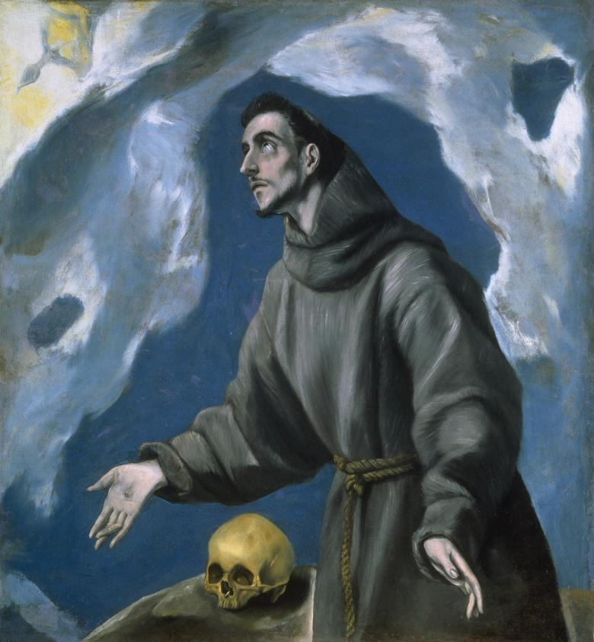In celebrating the Centenary of the Gift of the Stigmata as a Franciscan Family, we are invited to restore the dimension of prayerful and contemplative silence in our daily lives, the silence that places us before the essential, that lets us recognize our desire for the infinite that resides in our hearts, that allows us to listen to ourselves, to others and to God. In fact, even today, the Poverello is presented as a person who made listening a way of life: “Saint Francis heard the voice of God, he heard the voice of the poor, he heard the voice of the infirm El Greco (National Gallery of Ireland)
and he heard the voice of nature. He made of them a way of life. My desire is that the seed that Saint Francis planted may grow in the hearts of many” Pope Francis (Fratelli tutti 48).
All sing: Jubilate Deo….

Missionary Sisters of the Holy Rosary Centenary 2024 Sr. Franca Onyibor MSHR
Celebrate the past with Gratitude, Live the present with Passion,
Embrace the future with Hope
Sr. Franca Onyibor, the Congregation’s first African Congregational Leader, speaks about the centenary of foundation as “a time to give thanks for the countless lives that have been touched and transformed through our ministries. It is also a time to pay tribute to and acknowledge the enormous support, financial and otherwise of so many benefactors, over the past one hundred years”.

All sing: Jubilate Deo…

Prayer of Thanksgiving, Gratitude and Hope
Let us pray,
We give thanks to God:
for calling us to consecrated life
for challenging us along the way
for being with us at every step.

We express gratitude:
For those we were invited to serve
For our prayer-filled communities
For the many blessings we received

We live in hope:
That God’s plan for the future will bear fruit
That Jesus will help us build communities of justice and love
That God’s Spirit will set our hearts on fire again.

Song Dominican Magnificat (Feargal King)

Concluding Blessing Archbishop Dermot Farrell
Let us pray,
Be a bright flame before me, O God.
a guiding star above me.
Be a smooth path below me,
a kindly shepherd behind me.

May the blessing….

Song Praise the Lord, All You Nations (Fintan O’Carroll)

