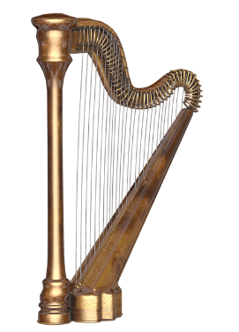**Songs of Praise – 23 September 2024**

**Monastery of St. Alphonsus**

**Psalm 150**

**Praise the Lord.**

**Praise God in his sanctuary;  
    praise him in his mighty heavens.  
Praise him for his acts of power;  
    praise him for his surpassing greatness.**

**Praise him with the sounding of the trumpet,  
    praise him with the harp and lyre,   
praise him with timbrel and dancing,  
    praise him with the strings and pipe,  
praise him with the clash of cymbals,  
    praise him with resounding cymbals**

**Let everything that has breath praise the Lord.**

**Prelude Te Deum (Marc-Antoine Charpentier)**

**Callum Byrne/Teresa O’Donnell/Ciarán Donegan**

**Song On Eagle’s Wings (Michael Joncas) Emmanuel’25**

**All sing: And He will raise you up on eagle’s wings**

**bear you on the breath of dawn**

**Make you to shine like the sun**

**And hold you in the palm of His hands.**

**Song All Are Welcome (Jesse Manibusan) Emmanuel’25 All sing: All are welcome in this place**

**Behold Love’s amazing grace**

**All are welcome! All are welcome!**

**Bring your hopes, bring your dreams.**

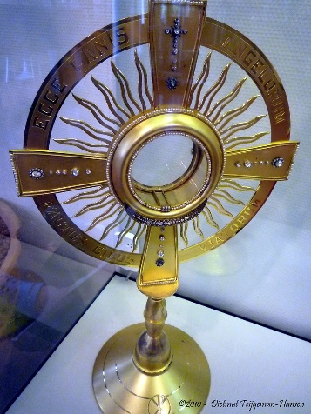 **Mercy flows and Love redeems!**

**All are welcome! All belong!**

**Instrumental Adoration (Florence Smith Price)**

**Reflection Sr. Máire Bríd O.Ss.R**

**Song Críost Liom (Bernard Sexton) Emmanuel’25**

**All sing: Críóst liom, Críost romham, Críost i mo dhiadh**

**Críost istigh ionam,**

**Críost liom, Críóst fúm, Críost os mo chionn .**

**Song Laudate Dominum (Taizé) Laudate’25**

**All sing: Laudate Dominum, Laudate Dominum,**

**Omnes gentes, Alleluia! (2)**

**Instrumental La Follia (Corelli/Geminiani)**

**Song Water of Life (Marie Dunne CHF) Laudate’25**

**All sing: Come to the water, you who are thirsty,**

**Come to the water of life.**

**Though you have nothing, I am your all,**

**I will hear you when I call.**

**Instrumental Emmanuel (Michel Columbier)**

**Song Shelter Me (Michael Joncas) Laudate’25**

**All sing: O shelter me, O shelter me:**

**the way ahead is dark and difficult to see.**

**O shelter me, O shelter me:**

**All will be well if only you will shelter me.**

**Instrumental Reflection on St. Carlo Acutis Séamus Ong**

**Song How Great Thou Art (Hine/Redman/Wong) Emmanuel’25**

**All sing: Then sings my soul, my Saviour God to Thee,**

**“How great Thou art! How great Thou art!”**

**Song A Hymn for Bedtime (Ian Callanan) Emmanuel’25**

